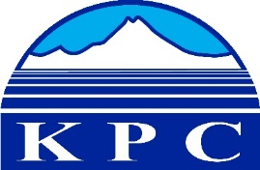
KENAI PENINSULA COLLEGE
COLLEGE COUNCIL REPORT
April 16, 2020
RBES-Seward, 6:00 p.m.
Department: Division Chairs
Prepared by: Marci Lea
5.12

Clair Kochis – Mathematics
In response to the COVID-19 pandemic and the resulting changes and challenges it presented to students, I switched to hosting virtual office hours on Tuesdays and Thursdays that have benefited more of my students than the same office hours hosted in person on campus. I also implemented a back-up plan for proctoring tests using Zoom when unprecedented demand for online tools such as RPNow and MyMath Lab resulted in the tools not being available for extended periods. By hosting extended Zoom meetings on Sunday March 29th and Monday March 30th, I was able to place seven students into breakout rooms and proctor their exams for them so that they could complete their exams on time. This virtual proctoring will also be offered in cases where students only have Chrome books and no access to a different computer that is able to support the RPNow remote proctoring tools.

Taz Tally
KPC’s adjunct professor of geology Taz Tally was selected as the 2020 Fall Artist in Residence for Great Sand Dunes National Park. Taz was an integral part of KPC’s digital art program for several years. He currently teaches geology courses for us and has taught courses in digital photography and digital image processing. His understanding of how natural geologic forces give rise to unique and captivating landscapes paired with his own creativity and love of the outdoors has allowed him to build a portfolio of artwork that captures the beauty of the world around us. Taz has provided the following information about the program itself and what this incredible honor means to him.

The Program:
Each year the Great Sand Dunes National Park and Preserve solicits artists to submit proposals to lead a Fall Public Program and display their art work at the National Park. This year, I submitted a proposal to offer a program on “Exploring the Great Sand Dunes National Park and Preserve with Your Smartphone.” Last year, I challenged myself to capture the Great Sand Dunes landscapes shooting exclusively with my iPhone and created an iPhone-captured Great Sand Dunes portfolio, which I submitted as part of my proposal. I was fortunate enough to be selected. I am honored to be chosen to assist park visitors in their explorations and artistic interpretations of this intriguing landscape of the The Great Sand Dunes.

Why I love to Visit and Capture the Great Sand Dunes:
The realm of The Great Sand Dunes National Park and Preserve provide wonder-filled opportunities for adventures in both natural science exploration and artistic expression. The Great Dunes, located in south central Colorado on the eastern edge of the massive San Luis Valley, are tucked up against the base of the towering Sange de Cristo Mountains that have been uplifted along the northern end of the Rio Grande Rift system where North America is being spread apart. The fascinating abstract forms of the sand dunes provide stunning visual and textural contrasts with the surrounding mountains and forests, and particularly during the colorful autumn season.

The program is scheduled to be held on Oct 3rd, 2020 at Great Sand Dunes National Park and is included on the Great Sand Dunes National Park and Preserve Calendar.

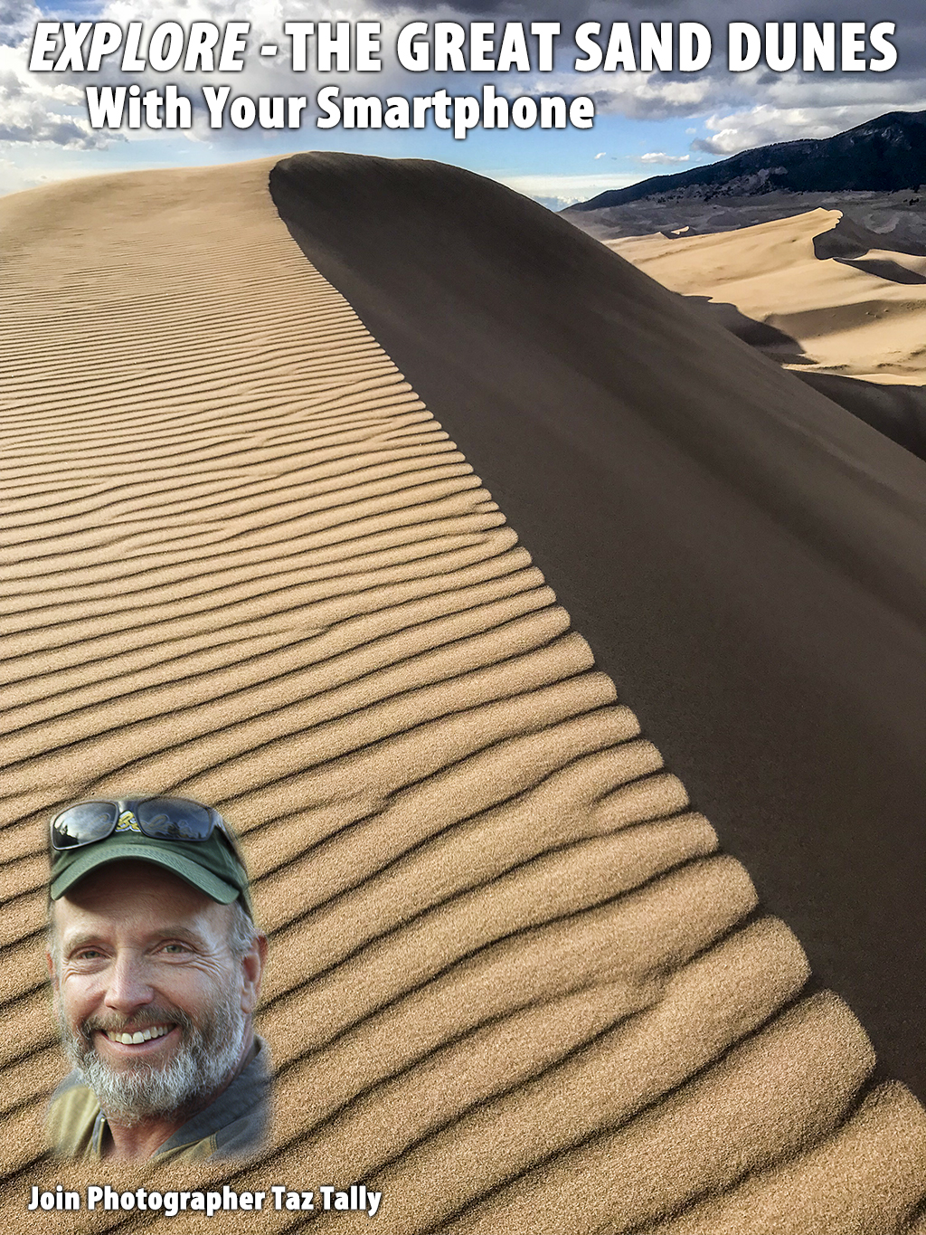

Henry Haney – Business and Industry
The Business and Industry group made necessary adjustments in teaching styles due to the Coronavirus.
The instructors suspected there might be a full shut-down and had begun preparing two-weeks ahead with viable alternate instructional delivery methods.

Many classes in B & I were already on-line distance courses or were being taught as blended classes. These have continued ahead with necessary modifications such as converting tests to an open book format.

Classes in PRT and IPIN that had F2F components such as hands-on lab projects have been restructured with short lab video’s and project assessment sequences to facilitate student learning.

One of the instructional software companies we work with offered to help providing temporary access to their licensed programs for students at home.

The Instructors and the Videographers were designated as “essential” employees and have been working at the CTEC Building to video classes. No students are allowed.

The AES Admin person in Anchorage (working from home) has been working extensively with instructors putting former F2F classes into an on-line Blackboard format.

Welding has had to continue as a F2F class but is going through extraordinary efforts to comply with the necessary social distancing and disinfecting procedures so they can finish out the semester.

Students have quickly adapted and adjusted to all the changes. The only “universal” complaint has been due to the slow-down of the Blackboard system. This is the result of the amount of on-line traffic now occurring on the internet system statewide, the UAA IT system, and on the Blackboard site.

Encouraging sign looking ahead Summer registrations are happening, and students have begun registering for Fall 2020 semester classes.

AKNS/Languages/CED/PER
Christina Stuive

Ahtna Language
- Ahtna language adjunct Sondra Shaginoff-Stuart invited Dawnland participant Esther Anne in my Ahtna Language class on March 23rd. She had a primary role in the creation and establishment of the Maine Wabanaki-State Child Welfare Truth and Reconciliation Commission and Maine-Wabanaki REACH. Dawnland is a documentary about the Maine Wabanaki-State Child Welfare Truth and Reconciliation Commission and was a response to the removal of Native peoples from their homes and communities. We have showed this documentary at KPC, and planned another viewing and Esther Anne was going to facilitate a discussion, but due to Covid-19 it is postponed. In the Ahtna course, she shared about parts of the film and what it was like working with survivors and some of community training around racism. She would like to come back in the fall and present the film again and join the classes. We thank her for her participation in the Ahtna course.
- Ahtna students have expressed their stress about the COVID 19 and having to work at home and how difficult it has been to manage family, work and class. Some are finding it hard to focus and they are not used to the online system.
- I have been able to assist Jeanie Maxim, Ahtna fluent speaker and Elder to join the Ahtna class on March 25th. She has joined the class since then. She brings an authentic way of teaching her language and stresses the importance of speaking our language not so much about the writing. I think that it is a good time for our class, and students have to switch their thinking, but it gives it a real sense of what the language feels like. Sondra has appreciated Jeannie’s daughter who is driving down to her place in the village of Gulkana, Alaska and helping her to sign into the class. It takes so many people for us to bring our language to the surface, as it is lying under ground when we use only the written.
- Sondra has been joining the Ya Ne Dah Ah Students and teachers in Chickaloon, AK as they are students who are learning and teachers instruct the Ahtna language over ZOOM Conferencing. They have a great first level class and it helps support me as a teacher as I am able to join in and share what I know and learn new languages that I am not able to practice while here in Kenai.
- Sondra has been working with an Ahtna student works for the School District at Cooper River, AK. She would like to set up a meeting with her administration to see how we can assist high school students to join our Elementary Class in the fall. I am working on a flyer to share and see if that meeting can happen.
- Sondra served on the Faculty search committee for the Anthropology professor.

Yup’ik
The Yup’ik faculty and Elder instructors Sassa Peterson and Lucy Daniels are working with Sondra Shaginoff-Stuart and special thanks to IT Spring Sibayan for all his technology assistance. It is a challenge to teach a language online and a double challenge to team teach from two different locations. They are doing it though!

Dena’ina
Sondra has also been liaising with the Dena’ina course to make sure F2F students have been transitioning to the changes and challenges of Zoom classroom.

AKNS General
Sondra wanted to share our Native student voices who have worked on and shared songs with our Kenai River Campus. I have highlighted them in my Rural and Native Student Service report, but I wanted to demonstrate how important it is for them to share the Yup’ik language with others. They wanted to highlight the Dena’ina Language too with a sign, in which we didn’t have a chance to record, but these ladies are very unique and special to our campus and I just wanted to share their video.
The Kahtna Yuratet (Kenai River Dancers) have created and posted a dance video that they would like to share with you: Kahtna Yaratet Dance Video

Spanish
Spanish has transitioned to distance learning. Adjunct Eva Canedo is positive about the transition and hopes for potentially utilizing distance learning in future language courses.

CED
Unfortunately, Fly Fishing had to be canceled due to Covid-19 and delivery method of F2F.

PER
- PER A213 Intermediate Pilates is being offered as a Special topics course this semester, the Pilates course has transitioned successfully to distance learning. Adjunct Sunday Stinson is excited about teaching Pilates as a distance delivered course. This course is on the agenda for UAB on Friday April 10 and should move forward to a permanent course. Thank you Sunday for all the hard work on creating a new course and jumping through all the hoops. Sunday shared this photo to remind us to breathe.
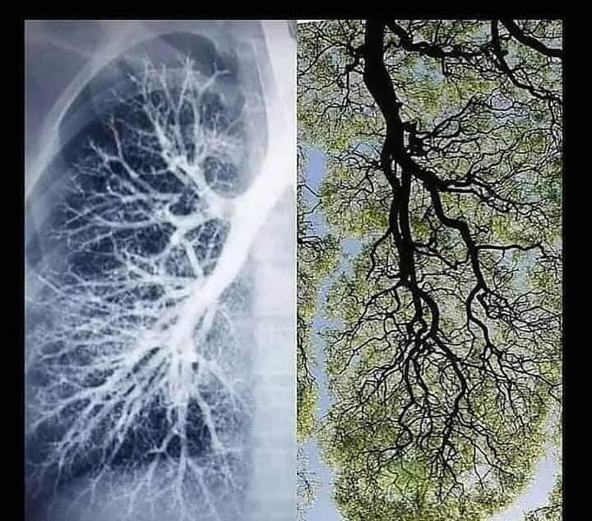
- Yoga adjunct Laurie Schaeffer shared these resources to be distributed to faculty, staff or KPC community to help with grounding in these difficult times.
  - Yoga International
  - Yoga Wall Sun salutation
  - Baxter Bell video
  - Dr. McCall
  - accessible yoga
- One of Laurie’s students said:
“My PER class (yoga) has been great. The instructor, Laurie, has been communicative from the beginning, offered extra "office hours" via Zoom, trial runs using Zoom, etc. She's very open to being new to this format to present a class, but it's gone very well. I've been thankful to have this little respite continue. The only real change is that we won't have a shared potluck at the last class. Thanks for checking, and kudos to instructor Laurie Schaeffer!”

HUMS – Bettina Kipp

Bettina Kipp reached out to students requesting a brief phone meeting, she recorded a video on my webcam for each class, explaining the alterations in assignments due to the additional week of spring break and the cancellation of face to face meetings, and including some encouraging words and posted them on Blackboard. This has taken a great deal of time, to learn and implement alternative methods, revise course assignments, contact students and help them with resources for the technology, but it has been effective. Every one of her students responded to requests for contact and are all on board for online through the end of the semester, which is a relief since human services people aren't always people who find virtual methods intuitive to use (including me). While the overall mood is more somber than usual, students are hanging in there and staying in contact. A very kind non-traditional student wrote to me:
"Hi Bettina, I finally got the video to come through on a different computer. I would like to set up my zoom presentation with you, just let me know how and when. I must say your inner light really comes through on your videos which is very supportive. Thank you!"
It was great to hear that my students still feel connected.

Paramedic, EMT, CNA and Fire – Paul Perry
Paramedic Program: Some of the disruptions that have occurred in the program since COVID-19 has taken over our lives have been the suspension of classroom lectures, fire department ride-alongs and hospital clinicals for all of our students. This was initially seen as a crisis but was quickly followed by the faculty sitting down and developing a solution that would allow our students to continue in their educational pursuit to become EMT’s and Paramedics without a total disruption in their education. This is what we came up with:

- Face to Face Classroom lectures are suspended. Solution: Using ZOOM video conferencing software all EMT and Paramedic instructors began teaching their cognitive lessons during the normally scheduled classroom hours. Paul teaches online with the paramedic students Monday through Thursday from 9a-4p with the rest of the PMED faculty and staff (Tiffani, Ashley, and Keagan) joining in for the daily afternoon skills labs.
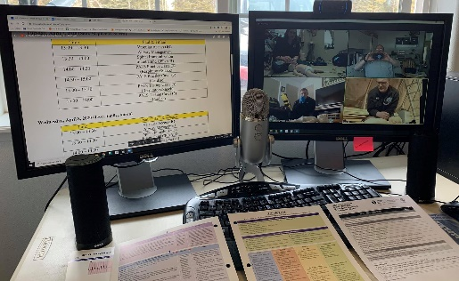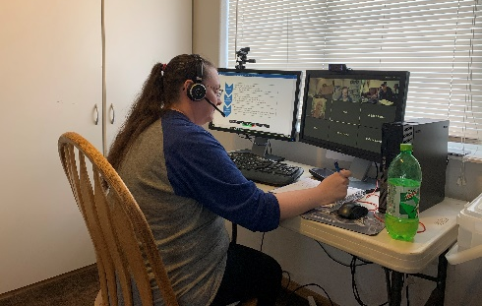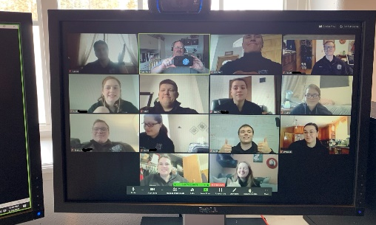
EMS Teaching Command Center, Tiffani at the Helm

- Problem: Skills Labs are suspended. Solution: We developed “Lab Buckets” that included all of the supplies and equipment students would need for each of the EMT-1, EMT-2 and Paramedic classes. The buckets also including disinfectant supplies so equipment could be cleaned and moved between students who are assigned to 4-member teams. The labs are held online using ZOOM video conferencing with 1 student from each squad (affectionately named “Team Soldotna”, “Team Kenai”, and “Team Nikiski”) attending each day after class for four (4) hours. Each lab was successfully completed this week with students using case studies, scenarios, and instructor lead skills check-offs that were previously scheduled. A huge “shout-out” to our EMS Lab Aids & Skills Instructors Keagan Whitcomb and Ashley Pass; they prepare the lab buckets each week, and without them we couldn’t be nearly as successful.
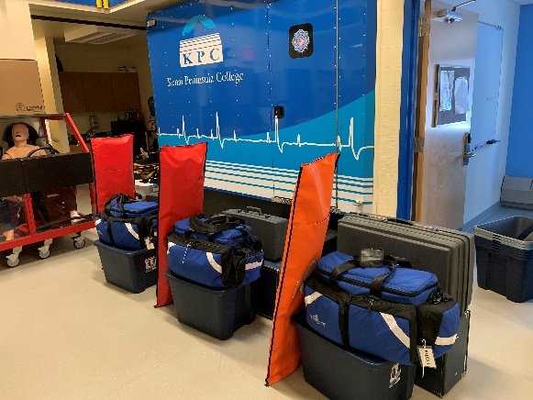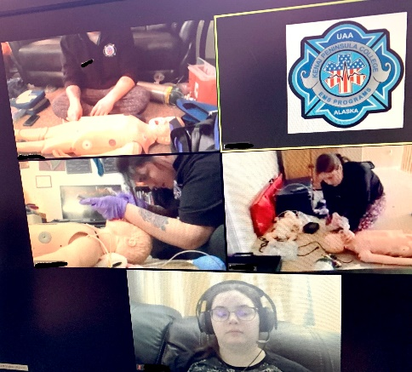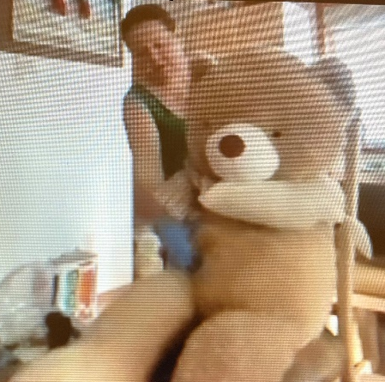
Lab Boxes Ready for Deployment PMED Students in Skills Lab EMT Student performing assessment

- Hospital Clinicals & Fire Department Ride-Alongs are suspended. Solution: Students had completed the majority of their required clinicals and ride-alongs for the semester so we moved the remainder of the course to web-based “Case Studies and Standardized Patients”. Students will basically move to a telemedicine format. We are using our Clinical Coordinator, and family members to act as “standardized patients” (online) where the students assess, examine, and develop differential diagnosis treatment plans. All “simulated patient contacts” count toward the program’s accreditation requirements. All diagnostic equipment is also available in the online conferences (i.e. cardiac monitors, ventilators and iStat lab analysis machines).
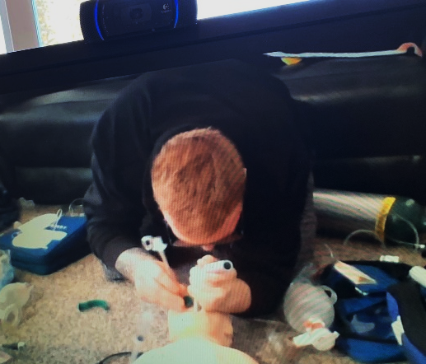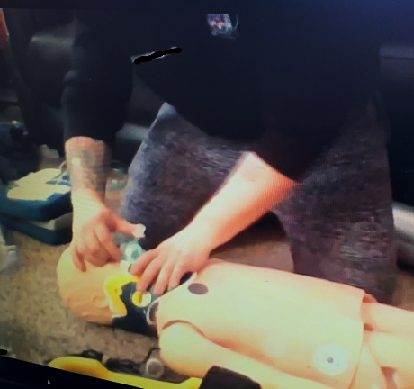
Paramedic Student Brandon E. demonstrates Intubation, Intraosseous Infusion, and Spinal Immobilization (Online)

- Out-of-State Field Internships are suspended. Solution: We recognize that students want to complete their paramedic training in a timely manner and we too would like to see that but at this time there are no students traveling to the lower-48 for their Capstone Field Internships until after August 15th so we have a little time to process this issue. The program’s standards (required for accreditation) and Alaska State Law require a 480-hour Capstone Field Internship and while the accreditors have approved moving this requirement also to simulation, the State of Alaska has regulations that have not yet been waived. State EMS Officials are working with the State Medical Board and the Department of Law to review these regulations if possible; however in the meantime we are actively working on the “what-ifs” that may need to be put in place if they need to be implemented. State approval does not mean that the KPC Paramedic Program will implement a Virtual Capstone, but it’s on the table none-the-less.

- Certifications Courses: Pediatric Advanced Life Support (PALS), Prehospital Emergency Prehospital Provider (PEPP), Advanced Medical Life Support (AMLS), and Prehospital Trauma Life Support (PHTLS) are all required national level certification courses that must be completed within the paramedic program. Each of these courses offers a Hybrid option so we transitioned to this modality for each certification. The skills component of each of these courses are now being completed online in the skills labs. The program picked up the cost to transition the students to the hybrid format.

- National Registry & State Licensure Exams: Starting the end of June, paramedic students were to begin taking their National Registry Psychomotor Exams. These are obviously on hold, but once the students complete the program and take their national written exam, in the KPC Testing Center, they will be issued a National Registry “Provisional” paramedic certification until such time as the candidate can take a full practical exam. The State of Alaska is doing similar provisional certifications for the EMT’s who complete their courses as well.

- Support for Central Peninsula Hospital. The Paramedic, CNA, and Nursing Programs were called on to support Central Peninsula Hospital with needed PPE Supplies and we were ready to help! The EMS Programs donated 6 cases of exam gloves (6000 total), Sixty (60) N-95 masks, 30 pairs of safety glasses, and 45 isolation gowns. Later CPH asked to borrow the college’s training hospital beds and ambulance gurneys. The nursing program loaned them 4 hospital beds and the CNA Program supplied another two (2). The hospital decided not to take the ambulance gurneys at this time but they are ready should the need arise in the future.

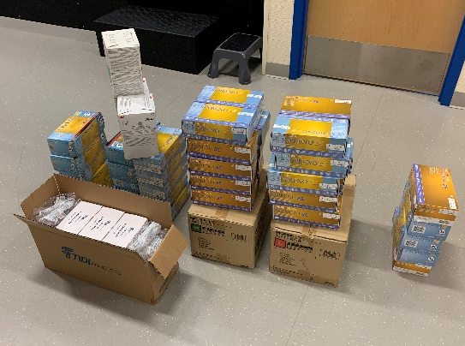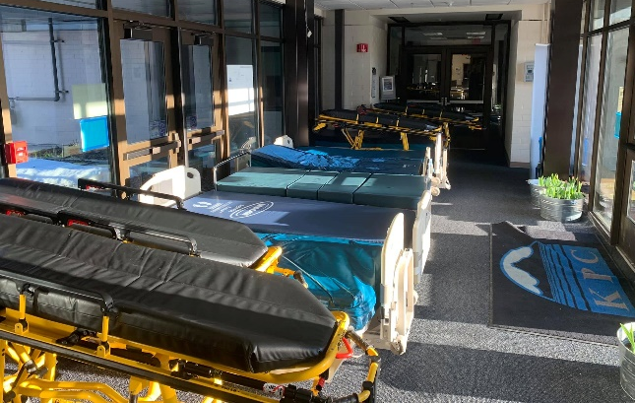
PPE Supplies & Hospital Beds for Central Peninsula Hospital

Emergency Medical Technician Programs (Tiffani Perry & Ashley Pass, Instructors)
- The EMT classes also have “Lab Buckets” and meet one-on-one with their instructor (rotating their bucket) daily after class via Zoom video conferencing to complete their scheduled lab tasks.

- Both EMT-1 and EMT-2 Students will take the class “Final Exams” next week which will serve as their State of Alaska EMT Written Exam. Faculty have also been requested by the state to attest to student’s skills competency at the end of class in lew of a psychomotor practical exam. The State will issue a “Provisional Certification” good for up to two years, or when the COVID-19 crisis is over. Full EMT certification will come after the student can again take the written and practical exam.

- All current EMT, and EMT Instructor licensures expiration dates were extended by Govenor Dunleavy by sixty (60) days, but could be extended again. This was nessessary as many State EMS Instructors (including KPC’s) were set to expire on 3-31-2020.

Certified Nursing Program (Audrey Standerfer, Instructor)
- The remaining two class meetings and comprehensive final examination to be conducted via zoom, which has been successful thus far. Skills portion of the program is complete, having been done prior to COVID-19 mandates. Clinical rotation will be postponed till clearance from CPH.

- Jumpstart CNA Program: Didactic portion of the program continues through use of zoom class meetings. Skills and clinical portion will be postponed/delayed till COVID-19 mandates have been lifted. Students are informed of this and have been given the option to drop the program. Matt Widaman, KPBSD liaison for program, is in agreement and Cheryl Siemers has been kept informed.

- The Alaska Board of Nursing has informed all CNA certification testing through April 2020 is cancelled due to COVID-19 mandates.

- Central Peninsula Hospital cancelled scheduled student clinical rotations till further notice.

