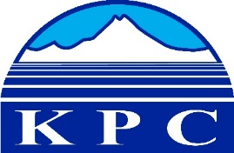
KENAI PENINSULA COLLEGE
COLLEGE COUNCIL REPORT
September 10, 2020
Zoom, 6:00 p.m.
Department: Division Chairs
Prepared by: Marci Lea
5.11

Clair Kochis – Chair of Math and Science

The novel corona virus created a number of challenges to higher education, but one of the most challenging aspects of the pandemic was determining how to maintain the quality of our instruction in laboratory science classes. KPC has historically offered face-to-face and blended options for our science labs that were either taught on a weekly basis (biology labs), or offered in two-day intensives during the semester (physics and chemistry labs). In many cases these face-to-face labs experiences were supplemented with lab kits that were mailed to students to be completed at home. When COVID forced campus closures, the science faculty at KPC, in collaboration with lab aide Maryna Roper, used their years of experience with blended at-home labs combined with their own scientific expertise to create at-home laboratory experiences for students that utilized common household staples and tools to deliver high quality and personally relevant laboratory experiences that did not require students to be on campus. This conversion from our usual lab offerings was completed in time to finish out the spring semester, fulfill lab requirements for the summer and be implemented for our fall courses as well. This effort clearly demonstrates the collaboration and excellence our faculty are known for.

Henry Haney – Chair of Business and Industry

Classes are still being affected by COVID19 conditions and resultant Level “B” protocols. Business and Industry was looking ahead and many classes were moved to “on-line” instruction, some have a “zoom” presentation, while other classes, due to technical hands-on nature of instruction, are going forward in person with full-time masks and social distancing.

It should be noted that social distancing at COVID19 Level “B” protocols changed the room capacities with only 25% allowed. Some classes have had to be moved into larger areas. Regular Labs and Lab Intensives will be following the Level “B” protocols.

Even with COVID19 class enrollments in Business and Industry have generally been good except for a few classes that are in the low part of their characteristic enrollment cycles.

This summer one new OEC in PRT was developed and approved. It is active this Fall 2020 and already has students admitted.

Some of the equipment is donated by Industry Partners to help develop “Upstream Operators” that will be used in the new OEC Training.

Lock-out / Tag-out training module.
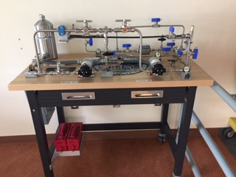

Gas Lift training module
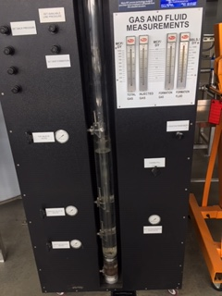

Lia Calhoun – Chair of Arts and Humanities

- Middle College: This department has been involved in the big push to prepare for Middle College students who are using our Comm 111 as the cohort group homeroom.
- Placement: We are using a new college readiness survey and writing sample to place students into appropriate Tier 1 GER classes in COMM and WRTG. 2 adjuncts (both former full-time faculty) are serving as readers. I am excited about this option as it gives us a more holistic picture of the student and their potential.
- Online Instruction: Online instruction is going remarkably well. Students seem well prepared for Zoom synchronous classes, and instructors are pleased with the capability of Zoom to allow for varied “classroom” activities. In my Zoom synchronous classes, I’ve noticed student participation being more robust than in the classroom in the past, and I’ve heard that echoed by other instructors. My own excitement for the semester is high, and I’m confident that nothing is going to be lost in this alternate mode of delivery.
- Professional Development: Our instructors have been tapping resources UAA-wide to assist in changes to instruction. A number of our instructors participated in #PIVOT and in ongoing workshops by KPC’s Educational Technology Team and have been implementing new tools in synchronous and asynchronous courses.
- Collaboration with main campus: We continue to work with English department on the main campus to facilitate the offering of the English major to our place-based students. I anticipate that the major will be available to our students by the 2021-2022 academic year.
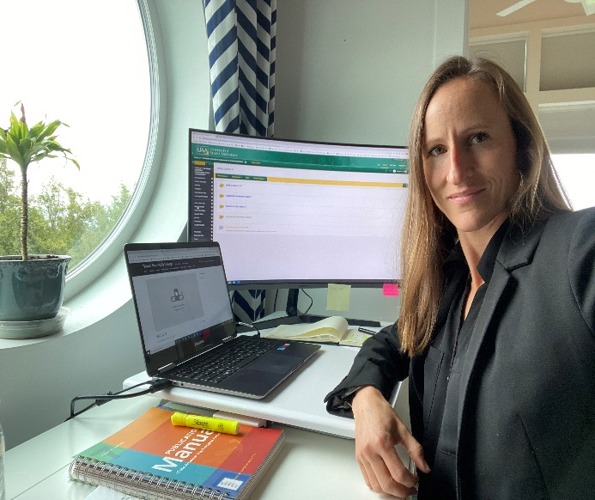
Professor Calhoun in her home office.
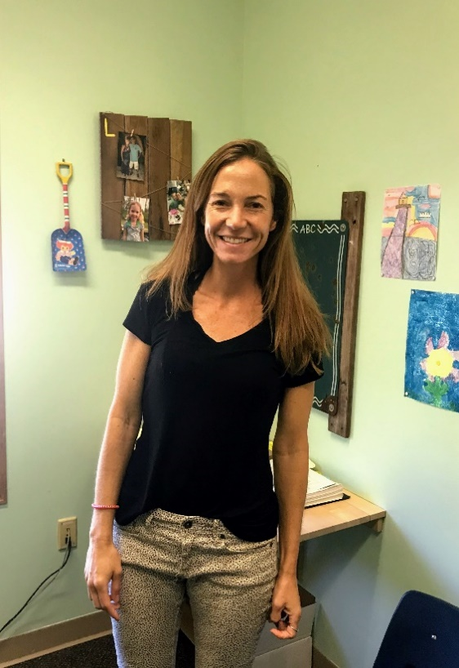
Professor Lohmeyer standing in her home office.

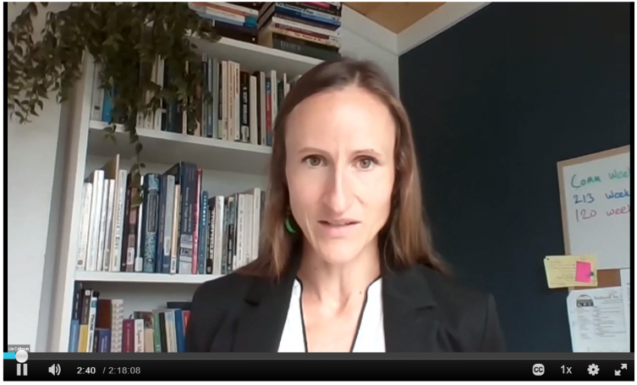

Screenshot of Zoom lecture.
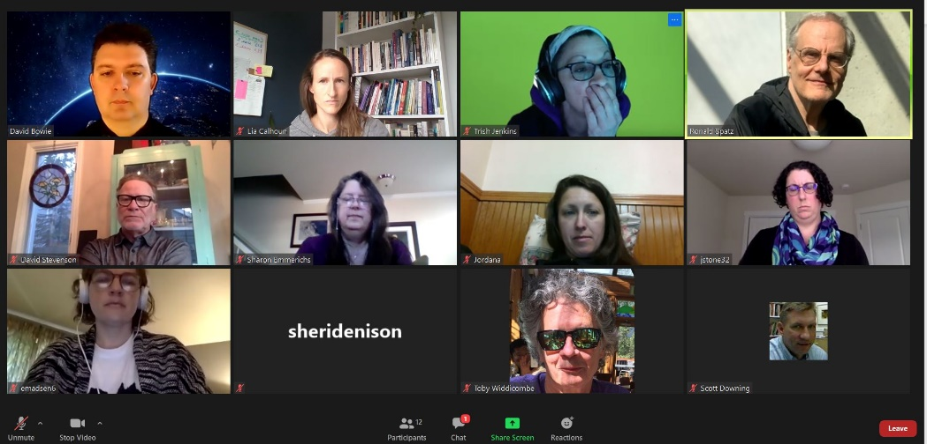
KPC English faculty discussing with main campus English faculty about how to make the English MA available to our place-based students

Robin Dahlman – Chair of Education and Social Sciences

We welcome two new full-time faculty members, Dr. Michelle Fellows and Dr. Adam Dunstan. Michelle is serving as our Psychology Professor and Adam as our Anthropology Professor.

Dr. Michelle Fellows is joining the KPC family from the faculty of the College of Western Idaho. She completed her undergraduate degree in Psychology at Boise State University and her graduate work at the University of Texas at Austin. Michelle's doctoral research was focused on emotional development in young children and she, therefore, enjoys teaching developmental and research/stats courses. Michelle loves to learn and thinks being a college professor is a great job because her main task is to make learning exciting for others, too. Her goal in her Psychology classes is to both expand students' understanding of human behavior and broaden students' employable skill set.

Adam Dunstan came to UAA/KPC in 2020, after previously teaching at the University of North Texas since 2015. He holds a PhD (2016) in anthropology from the University at Buffalo. A cultural and linguistic anthropologist, his primary foci include religion, the environment, and indigenous politics. Adam is thrilled to be at KPC, given its strong focus on teaching and collaboration with the peninsula community. Adam has a passion for teaching, informed by his own experiences as a first-generation college student and his conviction that appreciating human diversity is essential to living justly and working effectively in our complex world.

This fall we have solidified a key partnership with Kenaitze Indian Tribe to collaborate and serve in providing continuing education, certification, and degrees for personnel living and working with the education department serving our local community. This cohort currently has 9 students attending both Early Childhood Education and Alaska Native Studies courses through KPC. We look forward to continued growth and supporting these students in their educational pursuit.

Additionally, this fall we have all become accustomed to using Zoom to stay connected while needing to keep physical distance. Our faculty, both adjunct and full-time, all have enhanced their practices in delivery to best connect with and support students. Many have participated in the #Pivot initiative where we were able to expand our knowledge base and use of highly effective online delivery tools and practice. We are all off to a strong beginning!

As you may be aware, Faculty Chairs meet monthly. Here is a screenshot of one of our many gatherings:

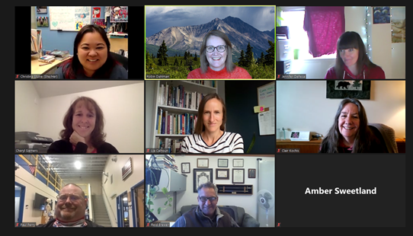

Christina Stuive – Chair of AKNS, CED, Languages

Ahtna Language
It is with great sadness that I report the passing of Jeannie Maxim, Ahtna Adjunct from KPC on July 8, 2020. Ahtna has lost another culture bearer. She assisted in the Ahtna writing and interpretation of the Ya Ne Dah Ah book with Dr. Siri Tuttle (of UAF). Here is a link of Jeannie talking about some of her knowledge regarding mooseskin tanning. youtube
Ahtna language continues to be taught through KPC, but our Ahtna instructor Sondra Shaginoff-Stuart is now a Term instructor for the AKNS department at UAA. While we will miss her presence here, we are excited for her expanded role in AKNS.

Yup’ik
The Yup’ik faculty and Elder instructors Sassa Peterson and Lucy Daniels have been assigned a Yup’ik class at UAA. Students from KPC transferred to that course as they had a full Yup’ik course that was left without an instructor. They will return to teach under KPC this Spring.

Dena’ina
Dena’ina has moved to a modularized hybrid format. They will be utilizing combined Zoom meetings and modularized material in a blended format for the first time.

American Sign Language
We are happy to welcome returning adjunct faculty Rebekah Schafli to KPC. ASL is a frequently requested course, but KPC has been unable to provide this course without an instructor. So welcome Rebekah (picture below)

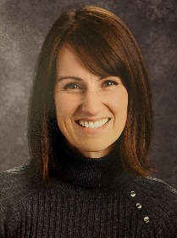

Japanese
Japanese has returned this semester with longtime adjunct Yasuko Lehtinen teaching Zoom classes for the first time.

Spanish
Spanish continues with Eva Canedo who is utilizing a Blended Zoom course for delivery.

