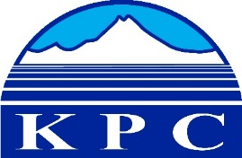
KENAI PENINSULA COLLEGE
COLLEGE COUNCIL REPORT
April 16, 2020
RBES-Seward, 6:00 p.m.
Department: KBC Director
Prepared by: Reid Brewer
5.5

- The majority of March and April have been tied up in planning, coordinating and logistics behind a coordinated response to the Covid 19 pandemic.
  - F2F faculty have been altering their courses for distance delivery.
  - Faculty and staff have been coordinating the logistics of working from home.
  - Staff developed protocols for students to access computer stations and/or internet access.
  - Staff developed a sanitation schedule to ensure that low traffic areas are cleaned and not used and high traffic areas are cleaned regularly.
  - Director developed and implemented essential status for faculty and staff using the UAA Employee tracker tool.
  - Director developed bi-weekly zoom session and email updates to all staff and faculty.
  - Director planning for future furlough potential.
  - Staff have planned parking lot, internet hotspots for spring and summer students.
  - SES staff emailed all students in KBC classes an advising newsletter providing multiple ways to contact support staff (video chat, phone, email). Additionally, all students in face-to-face classes were personally called to assess their learning, technology, and support needs as they transitioned to fully online classes. A second round of phone calls is happening now.

- IT techs Chesley and Ralph handled over 150 support requests via phone, email, Zoom, Teams and F2F in the week and a half between 3/23 and 4/1 in support of the work from home transition.

- Jennifer DePesa and Kim Frost are working on developing both a hard copy of the Fall 2020 KBC course mailer as well as an accessible on-line version that people can access.

- 16 students have been placed in SBB internship positions for Fall 2020 and 12 are currently planning for Spring 2021.

- Planning the scheduling for Fall 2020 classes completed, all full-time faculty Work Load Agreements signed and submitted.

- Kachemak Bay Writers Conference Director search
  - Search complete and Erin Hollowell has accepted and started work in April.
  - Erin is doing some broad scoping this spring and is formalizing an advisory committee.

- KBC is working the Bunnell Arts to organize a Land Acknowledgement Workshop
  - This workshop is a partnership with Bunnell in offering this training to get local organizations thinking about relationships of organizations with the indigenous ways of being.

- KBC staff are on the organizing committee with Kachemak Bay Marine Science Conference
  - First meeting of a six organization collaboration to plan the spring 2021 KBMSC.

- Alaska Adult Education FY2021 Grant Solicitation
  - Due to the Covid 19 pandemic, the AAE FY2021 Request for Proposals has been suspended. The Department of Labor will instead extend the last grant for one year.
  - Coordinated efforts in extending our grant with AAE programs from both KRC and KBC is underway.

- Community events
  - As a result of Covid 19 protocols, all public events were cancelled after March 11. KBC was scheduled to have a total of 74 events in the month of March as of closure date, up from 41 in February, a 45% increase. This is due to the bulk of non/credit and community classes taking place in March and April with each individual class counted as a separate event.
  - 21 events, 3/1-3/11 (total hours 53) (34.50 donated hours)
    - KBC or co/sponsored events - 4 (total hours 9)
    - Room use – 6 event (total hours 16)
    - Community classes - 2 (total hours 4)
    - Seminars/study sessions -9 (total hours 24)

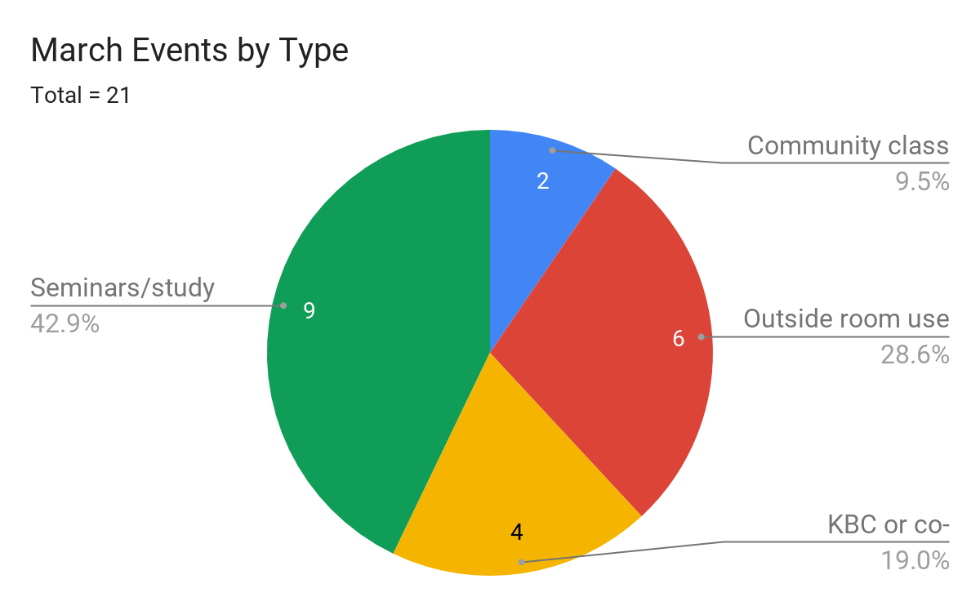

Community class | Outside room use | KBC or co-sponsored | Seminars/study sessions | Total # of events
2 | 6 | 4 | 9 | 21

Attendance at Community Events
- In March KBC saw 17% drop in attendance as compared to February which can be attributed to the closing of campus 11 days into the month. The events with the largest attendance numbers in March were the Solarize Community Brainstorm in partnership with Cook Inletkeeper (121) and the quarterly MAPP meeting (68).
- Total attendance = 300
    - KBC/co-sponsored events 145 (average = 36)
    - Room use 136 (average = 8)
    - Community classes 14 (average = 23)
    - Seminars/study sessions 5 (average = 2)
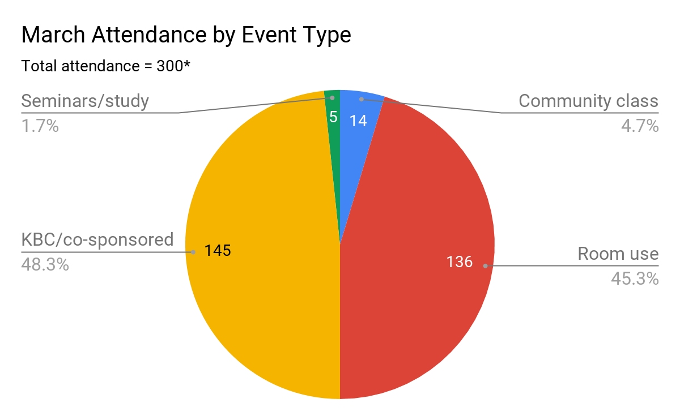

Community class | Room use | KBC/co-sponsored | Seminars/study sessions | Total hours
14 | 136 | 145 | 5 | 53

- Media for public events
  - This month our largest exposure were things listed in the Town Crier section of the Homer News, followed by our internal KBCNN broadcast system, and then Homer News calendar and KBBI. on 3/11.
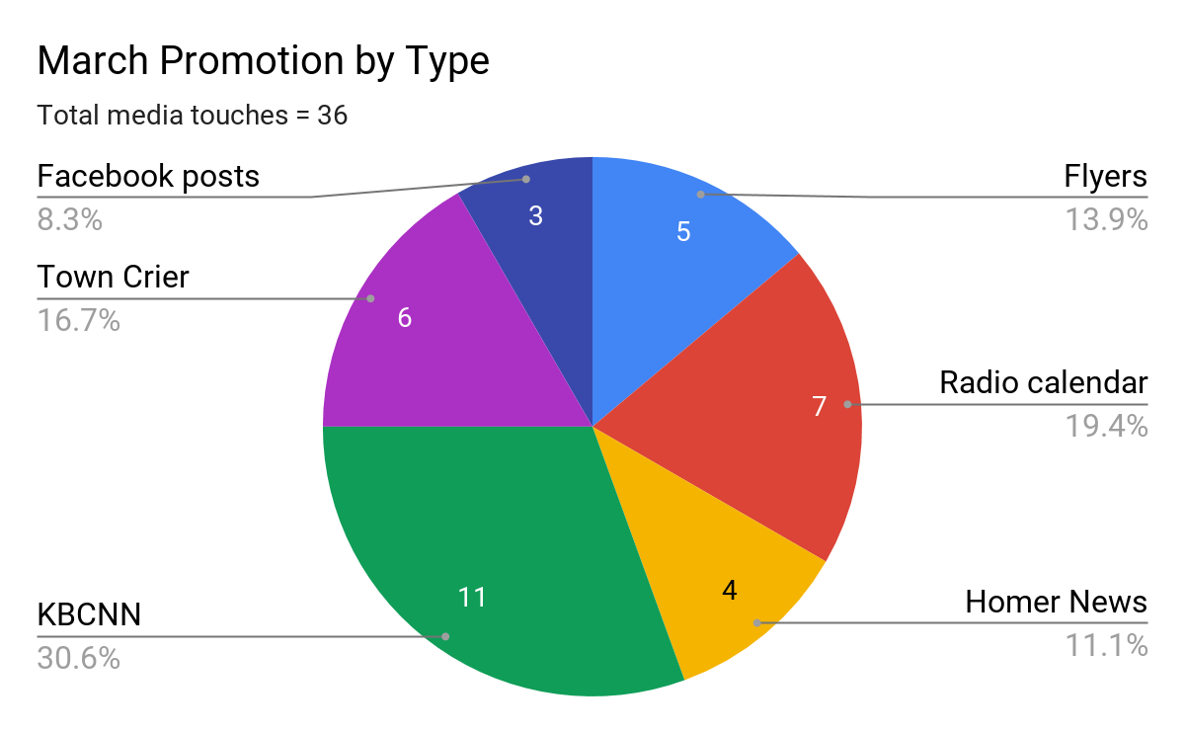

Flyers | Radio calendar | Homer News calendar | KBCNN | KPC/KRC Website (sent) | Print ad | Town Crier | Press Release | Facebook posts | total touches
5 | 7 | 4 | 11 | 0 | 0 | 6 | 0 | 3 | 36
Facebook posts in this chart represent only posts to support public events and not the total number of facebook posts generated by KBC. Also not pictured here are the KPC website, print ads, and press releases of which there were none in the first 11 days of March.

KBC hosted its first ever Zoom Game night on the 8th of April. 18 staff and faculty participated in a staff-inspired game of KBC trivia. Much thanks to our game-master Nancy Johnson!
