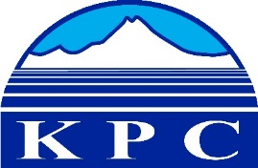

KENAI PENINSULA COLLEGE

COLLEGE COUNCIL REPORT
September 10, 2020
Zoom, 6:00 p.m.
Department: KBC Director
Prepared by: Reid Brewer
5.5

Fall Semester in Phase B
  - Normally KBC offers 60 to 70 sections of classes a semester but due to the challenging nature of alternate delivery we are only offering 51 sections in fall 2020. Courses like Painting, Skeletal Articulation, Ceramics and Welding could not be offered distance.
  - Though KBC is offering fewer sections of classes this fall and had to cancel the 15 credit Semester by the Bay program (mostly due to challenges with field trips and face to face work), we are only down about 15% for both Student Head Count and Student Credit hours for fall 2020.
  - In the month of August, the Kachemak Bay Campus Student Services team:
    - fielded slightly over 700 phone calls
    - proctored 19 Accuplacers and 3 misc. tests
    - Assisted 68 JumpStart students through the advising and registration process.
    - Direct Student Advising Contacts: 578
      - 200 phone
      - 68 Zoom
      - 310 email
  - The Kachemak Bay Campus went from 3 jumpstart students to 63 students in two weeks leading up to the beginning of fall classes.
  - Of the 25 full-time faculty and staff that work at the Kachemak Bay Campus, only 6 staff are on campus full-time for fall 2020. During the summer, all full-time faculty developed and incorporated tools to teach and record from home offices and all will be completely distance for the fall.
  - The Kachemak Bay Campus is using Google Sheets to account for 100% of campus presence. All full-time staff, testers, face to face students and faculty, and stop-in faculty and staff are recorded daily.
  - Doors remained locked, registration desk has plexi-glass dividers, students are escorted and logged in and out of classes, and used spaces are sanitized daily. (Fall2020)

  - 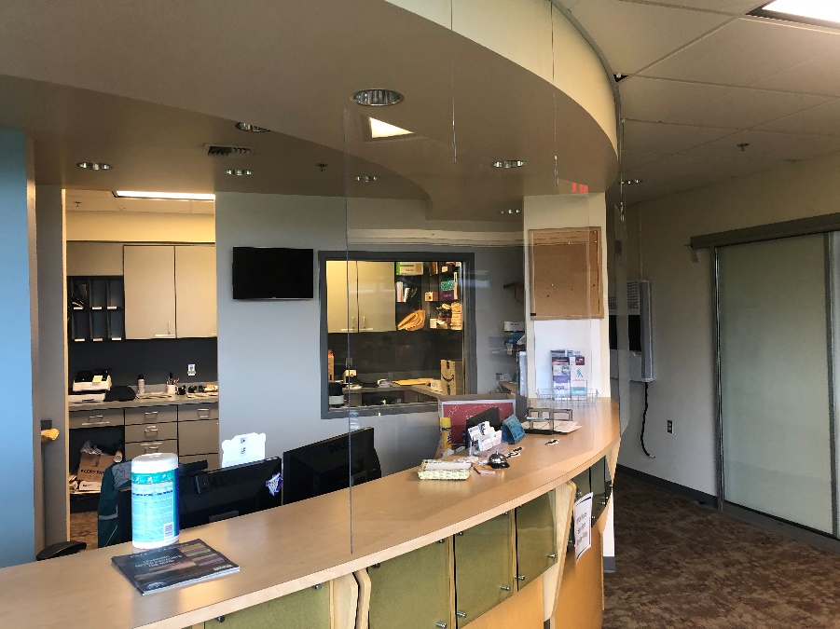

Face to Face courses at KBC
  - KBC is only offering two classes face to face in fall 2020. Certified Nurse Aide (CNA) and Nursing. All students and faculty are screened prior to entering KBC facilities, wearing masks when on campus, and spread in classrooms at 25% occupancy. Facilities are sanitized before, between and after classes. Nursing faculty are also taking students temperatures prior to entering KBC buildings and students are logging their temperatures. (F2F1, F2F2,F2F3)
  - 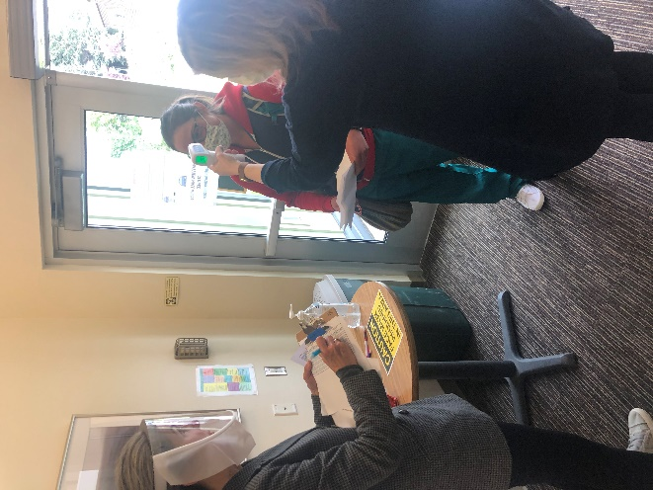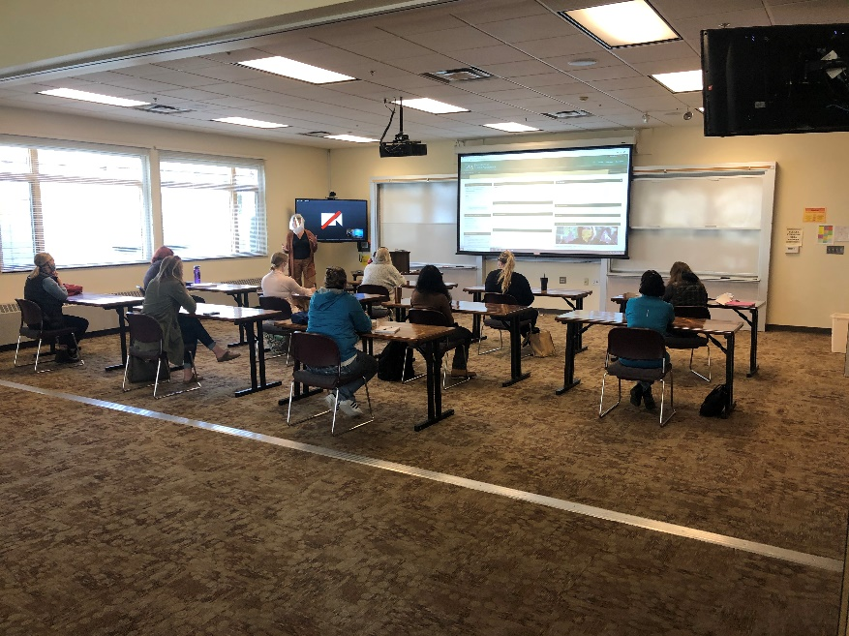
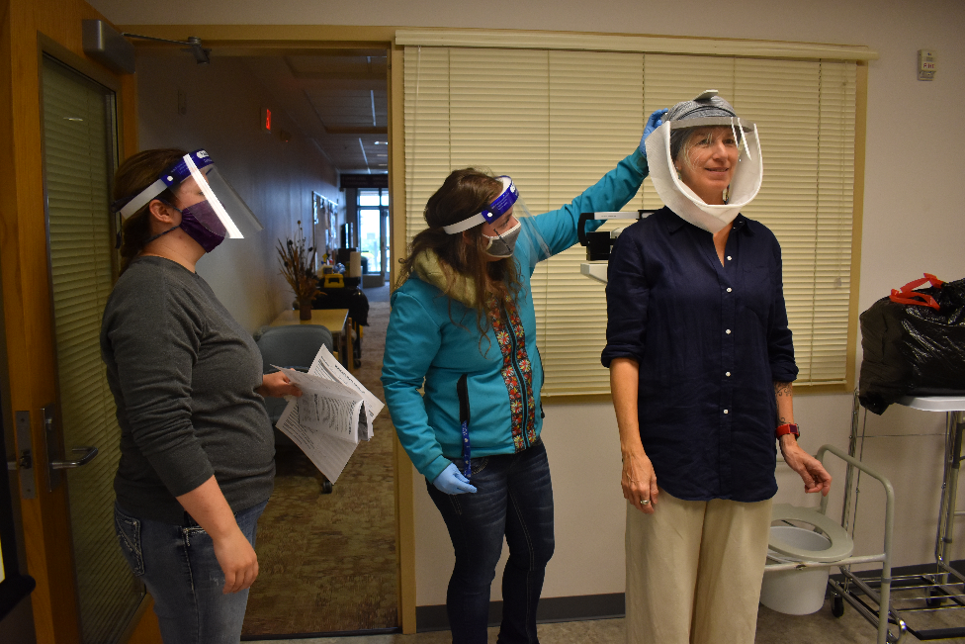

Semester by the Bay
  - If State of Alaska and University of Alaska Covid19 restrictions allow, in spring 2021 KBC will play host to 15 to 20 Semester by the Bay students that will be taking face to face courses in Conservation Ecology.
  - This will be the first time SBB will be offered in spring.
  - In July 2020, KBC Professor Debbie Tobin submitted two proposal for UAA Fast Track Career Certificates that were both accepted by UAA and are now catalog degree programs called Occupational Endorsement Certificates (OECs). One OEC will focus on the fall SBB program called Marine Mammal Biology and will train students to work in jobs like Veterinary Technicians, Marine Mammal Technicians (ex. Alaska Sea Life Center), Marine Mammal Observers, and many others. The other OEC will take place during spring and will focus on Conservation Ecology and will train students to work in jobs like Stream Technicians, Wildlife Biologists, Environmental Biologists and others.

Kachemak Bay Writers Conference 2021
  - Erin Hollowell joined the KBC family in April 2020 as the new Director of the Kachemak Bay Writers Conference. Erin has been working hard all summer to build an excellent and diverse advisory committee and has recently started approaching keynote and faculty potential for the 2021 conference. Erin is also planning for Covid19 contingencies.

KBC faculty to Pivot
  - All five of the full-time and three KBC adjuncts completed a week-long training this summer 2020 to learn about the latest online teaching tools in a training call Pivot.

Alaska Adult Education grant
  - Due to financial challenges associated with the university budget and the pandemic, the Department of Labor decided to extend the KPC Alaska Adult Education grant for one year. This grant pays for several staff to offer Adult Education programs at KPC to include GED prep and testing, writing skills and others.

Sea Otter video
  - Great Anchorage Daily News article that cites KBC professor Debbie Boege-Tobin
ADN Otter in boat
“If there was an otter in the mouth of the killer whale, the one in Dornellas’ boat could have been hopping in and out to check on it. But that’s only really likely if the otter in the boat was its mom, said Dr. Debbie Boege Tobin, a professor of biological sciences at the University of Alaska Anchorage at the Kenai Peninsula College, Kachemak Bay Campus in Homer.”

Baby Beluga
  - Natalie Rouse of Alaska Veterinary Pathology Services (AVPS) was assisted by Kachemak Bay Campus students Sara Kirlin from College of Charleston and Megan Owen and Alyssa Jzyk both from University of North Carolina Wilmington in an on-site necropsy of a baby beluga whale that was found near Captain Cook Recreation Area near Nikiski. The whale was transported back to Homer and processed by the students with help from Debbie Boege-Tobin, Jill Burnham, and KBC adjunct Lee Post. The spinal column was x rayed pro-bono by the Homer Vet Clinic to look for genetic anomalies. Later this fall the skull will be rearticulated and added to the KBC bone collection for teaching (Beluga1; left to right, Natalie Rause (AVPS), Megan Owen (UNCW) and Alyssa Jzyk (UNCW))
  - 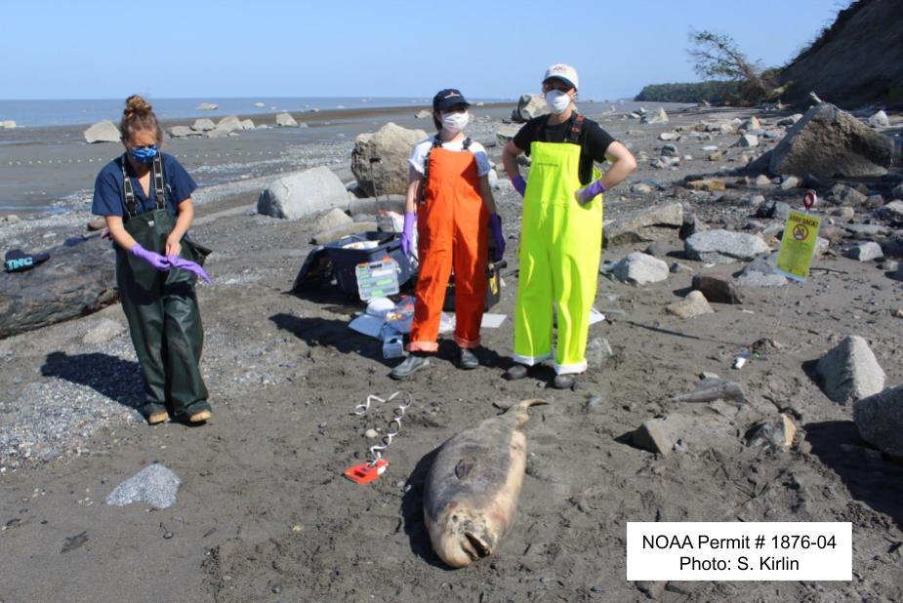

KBC faculty using Green Screen technology to teach
  - Jeff Johnson and Michelle Waclawski have been working to record lectures and meet with students using a program called OBS. You can check out some cool tutorials that Jeff put together below. These green-screen programs allow our faculty and staff to create effective and engaging content in this challenging and alternate delivery time.
OBS for video recording
A brief video on how to install the chromakey plugin

KBC Marketing
  - KBC staff have been working hard to market fall credit and non-credit offerings to let the public know that we are open for business. In July and August, KBC ran adds for general enrollment, Jumpstart, KPC scholarships, KPC services, and others. (marketing1, marketing 2)
    - 230 radio spots
    - 13 newspaper ads
    - 152 community calendar/Town Crier listings
    - 20 days of homer family theater marquee exposure
    - 24 Facebook posts
    - 5 events (Zoom and Facebook Live)
  - 