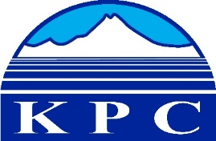
KENAI PENINSULA COLLEGE
COLLEGE COUNCIL REPORT
September 10, 2020
Zoom, 6:00 p.m.
Department: KPC Advancement
Prepared by: Alasha Brito
5.9

Social Media and Student Communication

Advancement continues to use social media as a way to get information to students. Dates, deadlines, important information, as well as fun photos of Alaska and KPC employees are shared on KPC’s social media platforms. Recently KRC and KBC decided to combine Instagram accounts and post together on that platform. The Instagram handle is kpc_ua. Both campuses will be working together to post photos and stories about KPC, its physical locations, employees, and students.
The kpcWORD will be published every Monday for fall semester and will go out to students, employees, and the community. The first issue was sent out on Aug. 24.

Advertising

Advancement is working with local radio, newspapers, as well as social media resources to increase the promotion of KPC. New radio commercial began broadcasting on several radio stations in the Central Peninsula Aug. 28 and more will be rolled out in the following weeks.

Connection

The first issue of the Connection is underway and will be published October 6.

KPC Website

With all the operations continuing mostly online for the fall semester there have been many updates needed on the KPC website. Some of those include:
- A new Student Accounts section (KPC Student Accounts) created with content expert Rob Knapp, Accounts Receivable Technician
- A KPC Covid-19 information page (KPC COVID-19 Info)
- Consolidation of the Bookstore page and a Bookstore link added to the main navigation pane that appears on the top of all the website pages

Accessibility
Advancement continues to work to maintain KPC accessibility standards and be available to assist with any digital accessibility questions, concerns or needs.

