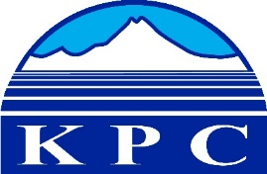
KENAI PENINSULA COLLEGE
COLLEGE COUNCIL REPORT
February 13, 2020
KRC - Soldotna, 6:00 p.m.
Department: RBES Coordinator
Prepared by: Jackie Marshall
5.7

Spring 2020 enrollments were extremely lean. Of the three face-to-face classes that I offered only Introduction to College Writing had adequate enrollment for the class to make. The good news is that this class made with an enrollment of 11 JumpStart students. Both the web-based courses that I offered were cancelled due to low enrollment.

Two JumpStart students received financial assistance to pay the cost of enrollment for their classes. One student was awarded $267 as a recipient of Seward PTA’s JumpStart Scholarship. Another student redeemed a KPC ‘Certificate Good for Three Credit Tuition Waiver’ to pay for her tuition balance for Spring 2020. The certificate was won at a drawing at the Seward High Financial Aid Night held in October hosted by Kenai Peninsula College – Resurrection Bay Extension Site.

Two non-credit classes have the interest of the community of Seward. Spanish for Travelers, offered for the third time, began January 28th with an enrollment of 12 students. Introduction to Pottery which begins February, quickly filled to capacity with ten students. Seven students are waitlisted.

I attended the 3rd Seward High School senior student and parent meeting of the year. Items highlighted pertaining to KPC were transcript request process, college application board, English and Math placement test and Kenai Peninsula College’s 2020/2021 High School Senior Tuition Scholarship.

Fall 2020 schedule is in process and will be completed by February 10, 2020.

