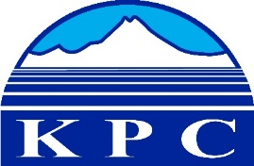
KENAI PENINSULA COLLEGE
COLLEGE COUNCIL REPORT
February 13, 2020
KRC - Soldotna, 6:00 p.m.
Department: KBC Director
Prepared by: Reid Brewer
5.5

- Assistant Professor Lia Calhoun was appointed to be the new KPC Chair of Arts and Humanities Department. Lia also serves as a KPC representative on the UAA University Academic Board and the KPC Leadership Committee.

- Nancy Johnson was appointed to the UAA Forum representing, KPC on both the Community Campus Staff Forum and Staff Recognition subcommittees.

- Assistant Professor Jeff Myers is continuing his work as the co-chair of the UAA Faculty Senate Community Campus Committee and the Board Chair of the Pratt Museum. Jeff is teaching a new 3 credit course in Spring 2020 called HIST A390: Terrorism and Organized Crime.

- Michelle Waclawski worked with Nine Star, an Anchorage-based education and employment service that works to help the under and un-employed improve their quality of life, to develop a Memorandum of Agreement so that KBC-based Alaska Adult Education students can have some of their education and/or training paid for by Nine Star. Since fall 2019, Nine Star has eleven students working with the KBC AAE staff.

- Professor Debbie Boege-Tobin and KBC Adjunct Marc Webber presented on the secret life of Kachemak Bay porpoises to a crowd of 70+ on January 24th. Debbie has been busy this winter personally reaching out to over 100 students that have expressed interest in next year’s Semester By the Bay programs and this summer’s AK Coastal Summer Institute.

- Jen DePesa has been organizing KBC adjuncts for Spring, Summer and Fall 2020. Starting this summer, KBC is expanding summer offerings through both full time and adjunct faculty.

- Jill Burnham, the KBC Events Coordinator, was asked to join the KPC Diversity Action Committee and Marketing Recruitment Subcommittee.

- KBC IT have been working on connecting audio and video for Pioneer 201/202 overflow so that invited speakers and presenters can reach up to 200 guests. KBC IT have also built and deployed three Zoom Stations in the KBC Bookstore area so that individual students taking courses via Zoom, can do so with minimal distractions.

- KBC IT with advice from Rob Lewis and Royce Bird are in the process of deploying 11 security cameras that will cover all entrances to Pioneer and Bayview, parking lot entrances/exits and commons study area.

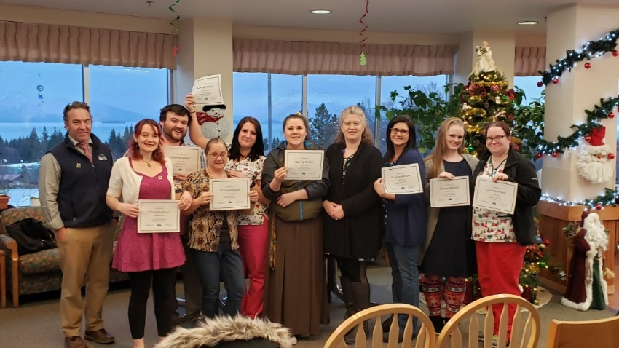
KBC CNA Pinning Ceremony at South Peninsula Hospital on December 12th

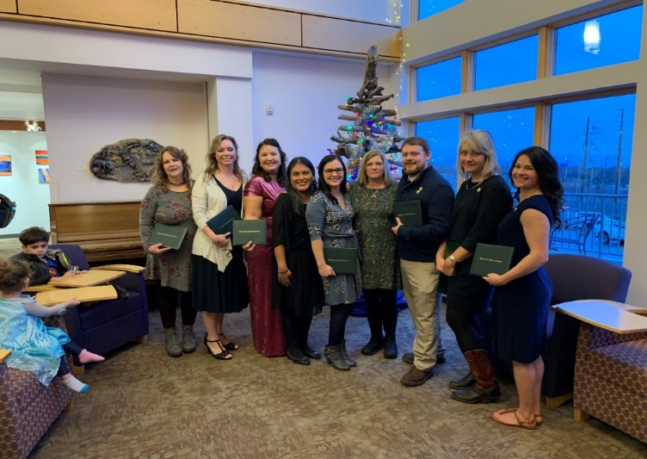
KBC Nursing Pinning Ceremony at KBC – December 14th

- KBC played host to UAA Facilities and Safety personnel on December 10th
  - Tim Edwards - UA Statewide Director of Safety
  - Beverly Shuford - UAA Vice Chancellor of Administrative Services
  - Chris McConnell - UAA Interim Director of Facilities, Planning, and Construction
  - Jeff Earle - UAA Chief of Police
  - Kim Mahoney - UAA Vice Chancellor of Facilities and Campus Services

- This Spring, 2020, KBC is offering 54 sections of courses, with seven courses VC’d to KRC, and 19 non-credit courses.

- In January 2020, KBC had seven local organizations use/rent KBC facilities totaling 17.5 hours with 182 in attendance. KBC also hosted 13 seminar/study sessions totaling 30.5 hours with 21 in attendance, including AAE drop-in classes, CFOS fisheries seminars and Weekend drop-in study sessions. For just the month of January, KBC has had over 600 people come through its doors for programs other than for-credit courses.

- KBC sponsored or co-sponsored seven events in January 2020 with 376 in attendance over 23.5 hours including:
  - Wildlife of the Pamir Mountains
  - SVT Thriving Thursdays @ AAE
  - Second Sunday Shakespeare
  - Women’s March After Party
  - Public Square
  - Marine Mammal Stranding Network Training
  - KBNERR Brown Bag Lunch
- KBC created a new story-telling series called Public Square. These events span the academic disciplines taught at KBC.
  - 21 November – Dar Jamal (Communication) discussed his journey from Alaska mountaineer to free-lance war journalist to climate reporter. 102 in attendance.
  - 11 January – Jon Ross (History) shared language, traditions and civil rights being reclaimed by Native People of Alaska. 65 in attendance.
  - 19 February - Dr. Michael Castellini (Natural Sciences) will tell stories and create a soundscape with recordings of marine mammals in and out of water, in rookeries and under ice. Dr. Castellini will also be giving a talk at KRC on his trip.
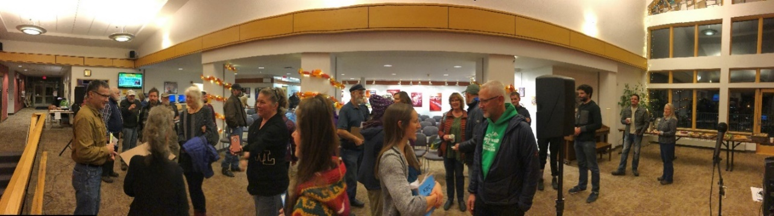

- After closing out a great Fall 2019 Semester By the Bay (SBB) program, SBB 2020 is looking good. After a huge marketing push in fall, KBC is anticipating an 80-100% increase in attendance for fall 2020 and a solid start for spring 2021 programs.

- For the second year, KBC hosted the after-party for the Homer Women’s March. Over 150 attended talks, work sessions and visited information tables. Twenty-one local and regional community/social service groups were a part of the event.

- On 11, January 2020, KBC played host to Homer Representative Sarah Vance who gave a public talk to approximately 115 community members. Representative Vance toured the KBC and talked with KBC Director Brewer about community campuses and the UA budget.

- KBC submitted a TVEP proposal for FY21 to continue to fund the KBC Maritime Coordinator position. This position organizes 15 to 20 classes a year serving between 150 and 200 students, many of whom receive USCG credentials.

- KBC submitted a Loss Prevention proposal to UA Statewide to partially fund the purchase of security cameras for the KBC campus. This proposal was funded for $9,670.71.

- KBC changing art gallery
  - KBC student art show 15 Nov – 6 Feb
  - Joe Kashi 7 Feb – current

- KBC along with Pier One Theater has started a program called Second Sunday Shakespeare. Each month community members of all ages get together to read and discuss a different Shakespeare play. The January reading was As You Like it, with 16 in attendance ages 17 to 70. The February reading is Midsummer Night’s Dream on February 9th. These events are free for all ages.

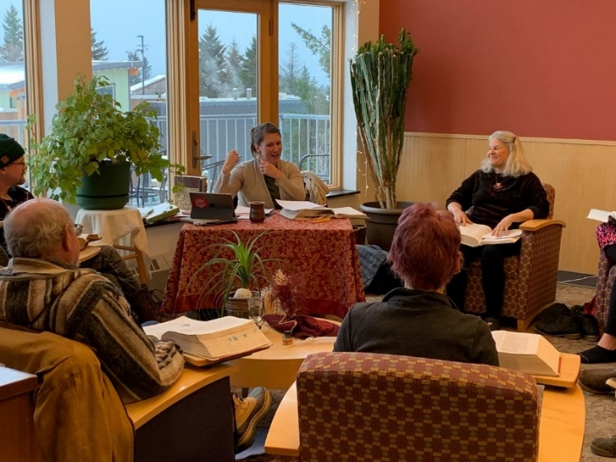

- KBC is planning the 2020 Spring Convocation Ceremony and is proud to have local writer and UAA faculty member Rich Chiappone as our 2020 Keynote Speaker.

- KBC is proud to have its first international student Winston Ajakaye from Nigeria.

- KBC had its first ever Ugly Christmas Sweater Party. Congratulations to Beau Calhoun for taking home first prize.

